TIMEKEEPING APP

Table of Contents

EMPLOYEE MANAGEMENT 2

Employee Table 2

Employee Details (Add, Edit) 2

TIMEKEEPING MAINTENANCE 2

Approved Overtime Table 2

Approved Overtime (Add) 3

Employee Schedule Table 3

Employee Schedule (Add, Edit) 3

Daily Employee Schedule 3

Import from Portable Device 3

Export TXT File 4

Import from Excel 4

Daily Time Record Maintenance Table 4

Daily Time Record Maintenance Summary 4

TIMEKEEPING REPORTS 4

FIELD MANAGEMENT 4

USER MANAGEMENT 5

# EMPLOYEE MANAGEMENT

Info: Employee/Ex Employee Record

## Employee Table

1. Employee No.
2. Full Name
3. Department
4. Location

## Employee Details (Add, Edit)

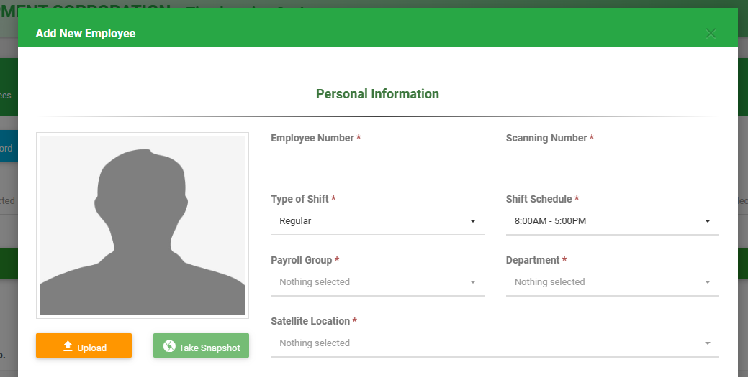

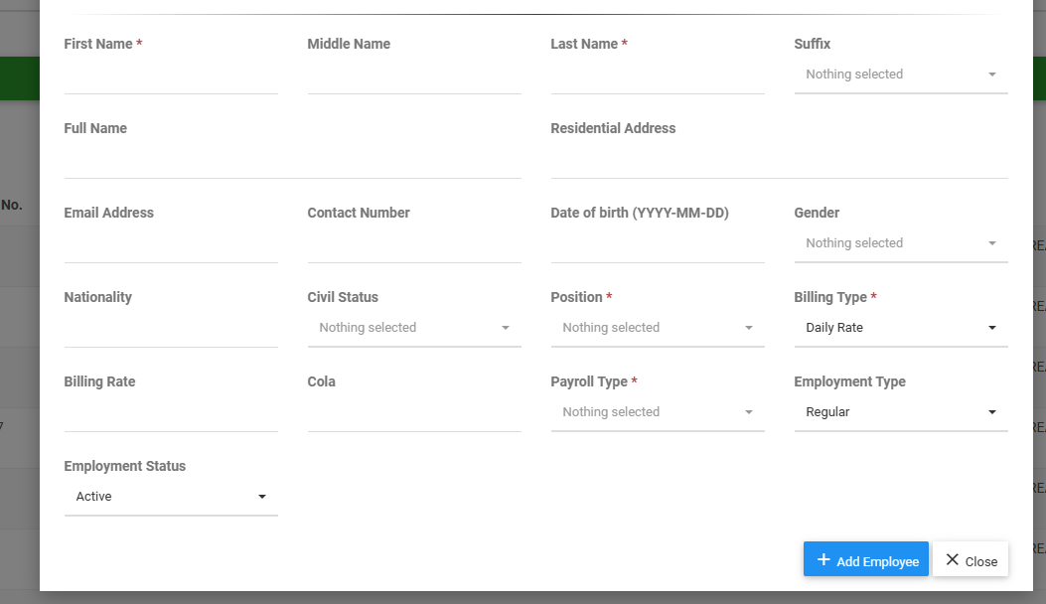

1. Employee Number
2. Scanning Number
3. Type of Shift
4. Shift Schedule
5. Payroll Group
6. Department
7. Satellite Location
8. First Name
9. Middle Name
10. Last Name
11. Suffix
12. Residential Address
13. Email Address
14. Contact Number
15. Date of Birth
16. Gender
17. Nationality
18. Civil Status
19. Position
20. Billing Type
21. Billing Rate
22. Cola
23. Payroll Type
24. Employment Type
25. Employment Status

# TIMEKEEPING MAINTENANCE

Info: Approved Overtime, Employee Schedules, Import from Portable Device, Export TXT File, import from Excel, Daily Time Record Maintenance

## Approved Overtime Table

1. ID
2. Full Name
3. Date
4. Time In (OT)
5. Time Out (OT)
6. Status

## Approved Overtime (Add)

1. Payroll Group
2. Department
3. Location
4. Employee
5. Approved Date
6. Approved By
7. Time In (OT)
8. Time Out (OT)
9. Remarks
10. Payroll Group 2
11. Department (OT)
12. Status
13. Upload Attachment

## Employee Schedule Table

1. Shift Code
2. Shift Description
3. Shift Type
4. Status

### Employee Schedule (Add, Edit)

1. Shift Type
2. Shift Code
3. Shift Description

### Daily Employee Schedule

1. Week Day
2. Time In
3. Break Out
4. Break In
5. Time Out
6. Working Hours
7. Break
8. Restday

## Import from Portable Device

x

## Export TXT File

1. Location
2. Payroll Group
3. Department
4. Date From-To

## Import from Excel

1. File
2. Select File

## Daily Time Record Maintenance Table

1. Scanning No.
2. Name
3. Location
4. Department

### Daily Time Record Maintenance Summary

1. Date
2. Day
3. Time In
4. Break Out
5. Break In
6. Time Out
7. OT In
8. OT Out
9. Special Case
10. Remarks

# TIMEKEEPING REPORTS

## Daily Record Report (Export)

* Select

1. Scanning No.
2. Employee Name
3. Employee Department
4. Employee Location

* Table

1. Date
2. Day
3. Check In
4. Break Out
5. Break In
6. Check Out
7. OT In
8. OT Out
9. Regular Hours

## Summary of Attendance (Export)

1. Scanning No.
2. Employee Name
3. Employee Department
4. Employee Location

## Summary of Billing (Export)

1. Scanning No.
2. Employee Name
3. Employee Department
4. Employee Location

## Billing Report

1. Scanning No.
2. Employee Name
3. Employee Department
4. Employee Location

## Raw Data

X

## Export to Excel

1. Scanning No
2. Name
3. Date
4. Time In
5. Break Out
6. Break In
7. Time Out
8. OT In
9. OT Out
10. Regular Hours
11. OT
12. OT Excess
13. ND
14. UT
15. NDOT

# FIELD MANAGEMENT

## Departments

* Table

1. Code
2. Name
3. Payroll Grouping
4. Status

* Add

1. Payroll Grouping
2. Code
3. Name

## Holidays

* Table

1. Date
2. Name
3. Holiday Type
4. Status

* Add

1. Date
2. Name
3. Holiday Type

## Payroll Grouping

* Table

1. Code
2. Name
3. Status

* Add

1. Code
2. Name

* Billing Rate
* Rates (OT)

1. Regular
2. Regular Overtime
3. SH/RD Overtime
4. SH/RD OT Excess
5. SH&RD Overtime
6. SH&RD OT Excess
7. Legal Holiday
8. Legal Holiday OT Excess
9. Legal Holiday & RD
10. Legal Holiday & RD OT Excess
11. Time Start
12. Time End
13. Maximum Allowable Time (hours)

* Rates (ND)

1. Regular
2. Regular Overtime
3. SH/RD Overtime
4. SH/RD OT Excess
5. SH&RD Overtime
6. SH&RD OT Excess
7. Legal Holiday
8. Legal Holiday OT Excess
9. Legal Holiday & RD
10. Legal Holiday & RD OT Excess

* Balmori (OT)

1. Overtime 1 – 10

* Balmori (ND)

1. Night Differential 1-10

* Config (ND)

1. Time Start
2. Time End
3. Maximum Allowable Time (hours)

## Positions

* Table

1. Code
2. Name
3. Daily Rate
4. Monthly Rate
5. Status

* Add

1. Code
2. Name
3. Description
4. Daily Rate
5. Monthly Rate

## Signatories

* Table

1. Signatory No.
2. Signatory
3. Position
4. E-Signature
5. Status

* Add

1. Signatory no.
2. Signatory
3. Position
4. E-signature

## Satellite Locations

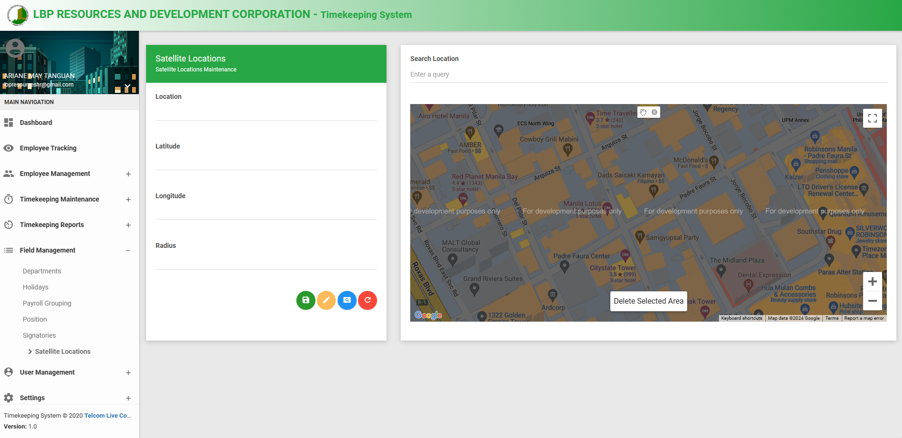

* Add
* Location
* Latitude
* Longitude
* Radius

# USER MANAGEMENT